# PROJECT REPORT

Project Title: Asset management portal

Team Name: Smart Assets Crew

TEAM MEMBERS:

Kanaparthi Bhanu Sri **: 23MH1A05H6(Team lead)**

**P Venkata Lakshmana Babu** : **23MH1A05K3**

**Vemana Chaitanya Satya Kumar : 23MH1A05L2**

**Gurajala Ameen Saheb :**

**Introduction:**

**Project Overview:**

**The Asset Management Portal is a simple web application that helps organizations keep track of their physical and digital assets. It allows employees to request items like laptops or tools, and lets managers approve, assign, and monitor those items. The system also shows asset status, sends alerts for maintenance, and keeps records of every asset from the time it is bought to the time it is no longer used.**

**Purpose:**

**The main purpose of this project is to make asset management easy and organized. It helps:**

**>Keep all asset records in one place.**

**>Avoid losing or misusing items.**

**>Save time by automating requests and approvals.**

**>Remind when an asset needs repair or replacement.**

**Ideation & Brainstorming Phase:**

**📌 Problem Statement:**

**Organizations often face difficulties in managing and tracking both physical and digital assets. Without a proper system, assets may be underutilized, misplaced, or not maintained on time. This leads to financial loss, operational delays, and poor decision-making due to lack of proper records and tracking.**

**💡 Proposed Solution:**

**We propose a web-based Asset Management Portal developed using Flask. The portal allows employees to request assets, while administrators manage asset allocation, maintenance, and disposal. The system keeps real-time records, automates assignments, and sends alerts for maintenance or replacement. Reports are generated to support tracking and decision-making.**

**🎯 Target Users:**

**. IT Administrators**

**. Operations Managers**

**. HR and Procurement Departments**

**. Employees**

**. Educational Institutions, Companies, Hospitals, etc.**

**✅ Expected Outcome:**

**. A user-friendly web portal to track and manage assets**

**. Automated alerts for maintenance and replacements**

**. Accurate, real-time data for decision-making**

**. Reduced asset loss and better utilization**

**. Increased operational efficiency and cost savings**

**Empathy map canvas:**

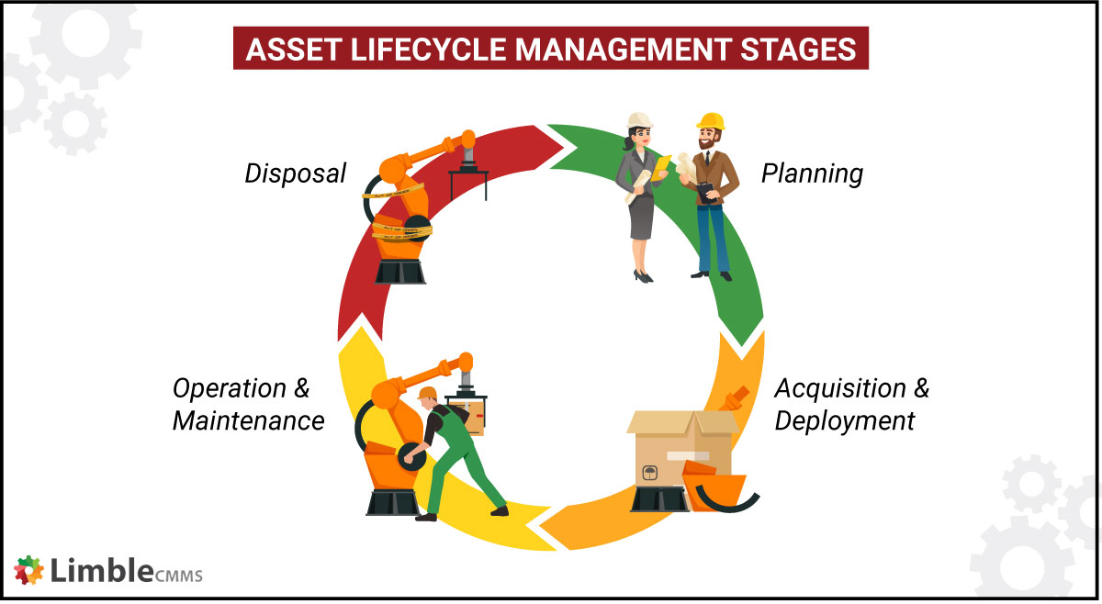

**Requirement Analysis:**

**Customer Journey Map:**

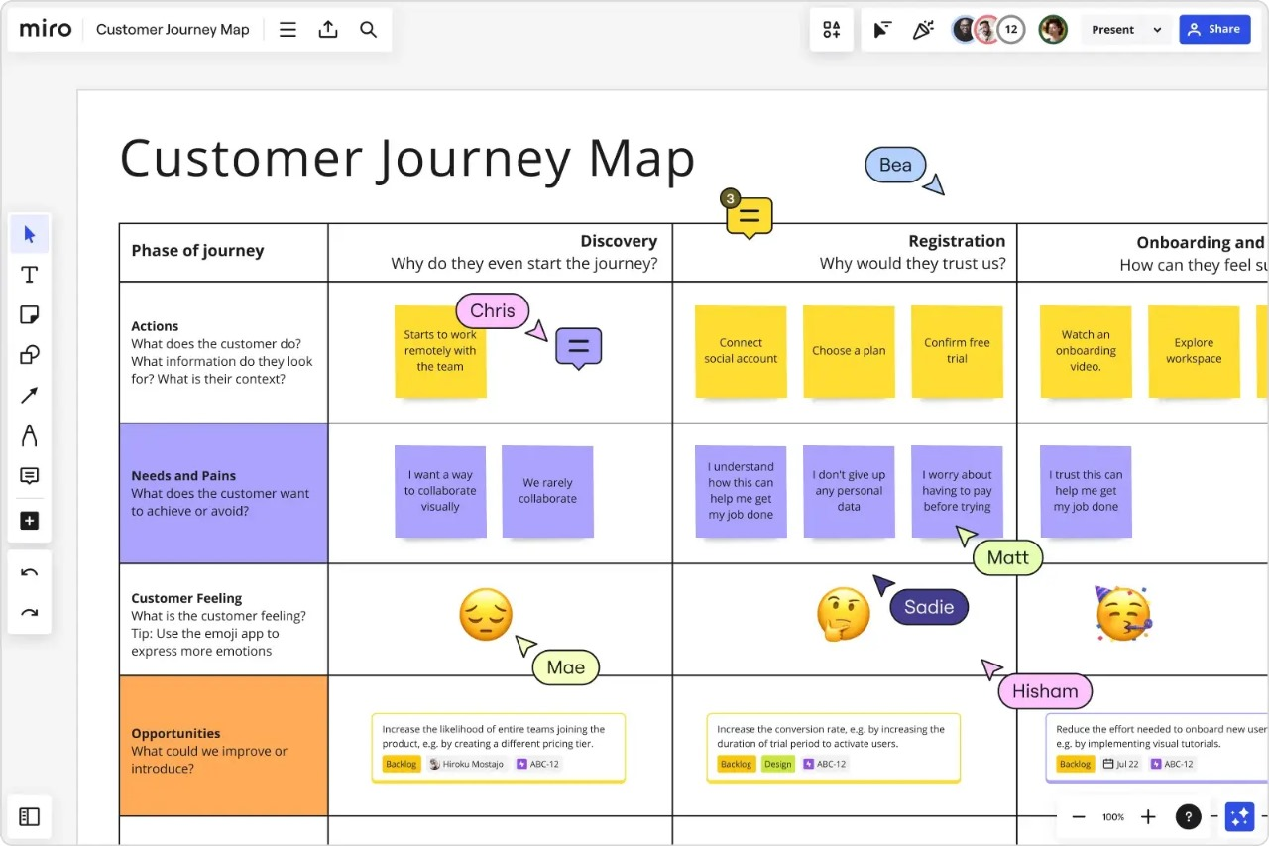

**Solution Requirement:**

**✅ Functional Requirements (What the system should do)**

**✅User login with role-based access (Employee/Admin)**

**✅Request, approve, and assign assets**

**✅Track asset status (Available, Issued, Under Maintenance)**

**✅Alerts for maintenance and replacements**

**✅Generate asset reports**

**✅Upload invoices or warranty documents**

**✅Search, filter, and return assets**

**⚙ Non-Functional Requirements (How the system should behave)**

**⚙Easy-to-use interface (web/mobile)**

**⚙Secure login and data protection**

**⚙Fast and responsive performance**

**⚙Scalable for large data**

**⚙Regular backups and recovery options**

**⚙High system availability**

**Data Flow Diagram:**

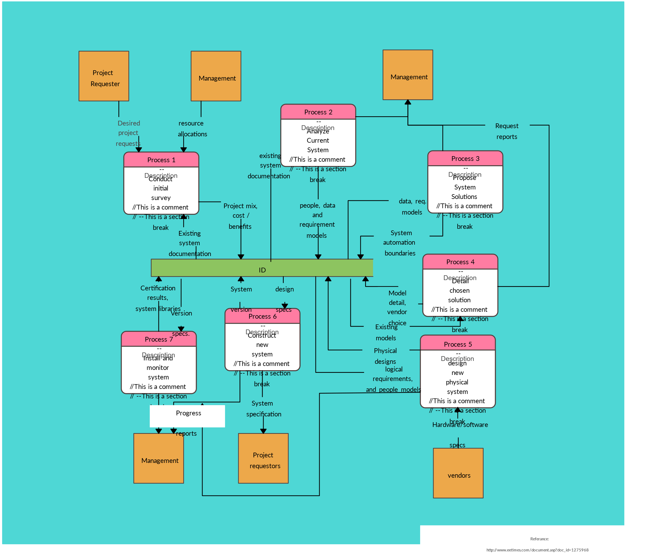

**Project design:**

**Problem Solution Fit:**

**Problem: Organizations struggle with manual asset tracking, lack of real-time updates, asset loss, and poor maintenance alerts.**

**Solution: A centralized ServiceNow portal that automates asset requests, assignments, and monitoring, ensuring transparency, timely maintenance, and improved efficiency.**

**🔧 Modules Used in ServiceNow:**

**Asset Management: Manages asset lifecycle (procurement to disposal).**

**Service Catalog: Allows employees to request assets.**

**Flow Designer: Automates approvals and assignments.**

**CMDB: Stores all asset details centrally.**

**Reports/Dashboards: Track utilization, condition, and maintenance.**

**🔁 Workflow Example:**

**1. Employee requests an asset via the portal.**

**2. Manager approves the request.**

**3. Admin assigns the asset automatically.**

**4. System updates records and sends alerts for future maintenance.**

**🎯 Benefits:**

**Automation reduces manual errors.**

**Real-time tracking and alerts.Better decision-making through reports.**

**Centralized asset data improves control.**

**Proposed solution and solution architecture:**

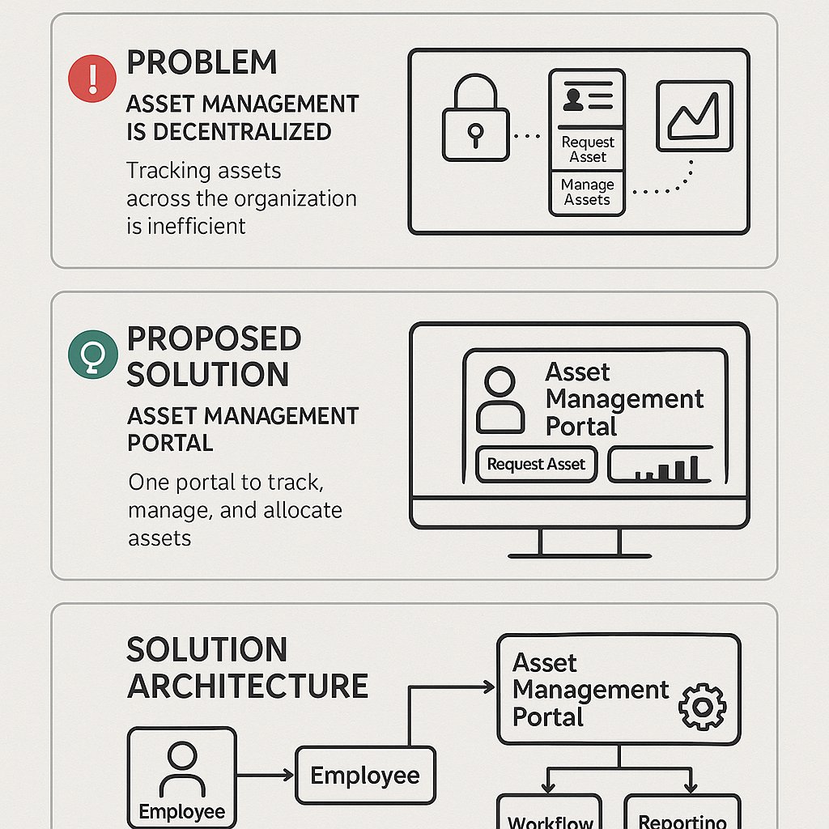

**Project Planning and Scheduling:**

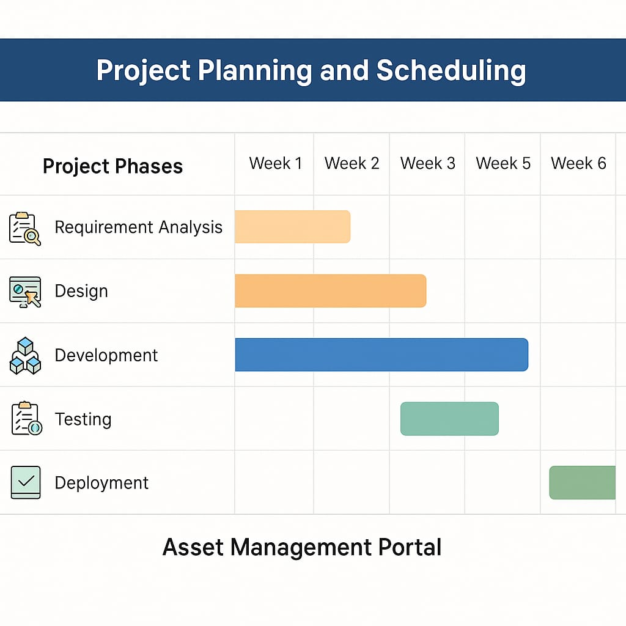

**🗓 Project Timeline: 6 Weeks**

**📌 1. Requirement Analysis (Week 1–2)**

**>Identify asset types (laptops, licenses, etc.)**

**>Understand roles (employee, admin, manager)**

**>Define goals for automation and reporting**

**📌 2. Design (Week 2–3)**

**>Design the user portal layout**

**>Plan Service Catalog structure (request forms)**

**>Set up CMDB relationships for asset records**

**📌 3. Development (Week 3–5)**

**>Build workflows using Flow Designer**

**>Configure tables and forms in ServiceNow Studio**

**>Enable auto-assignment and notifications**

**📌 4. Testing (Week 5)**

**>Perform unit and UAT (User Acceptance Testing)**

**>Validate all request, approval, and reporting flows**

**📌 5. Deployment (Week 6)**

**>Move solution to production**

**>Train end-users (employees/admins)**

**>Go live with real-time asset trackin**

**Functional and Performance Testing:**

**Functional Testing in ServiceNow:**

**Functional testing ensures the portal works as expected. It includes:**

**1. Login and Role-Based Access: Test if employees, admins, and managers see appropriate features based on roles.**

**2. Asset Request & Approval: Validate that users can request assets, and workflows trigger approvals.**

**3. Asset Assignment & Return: Check correct asset assignment, return tracking, and availability updates.**

**4. Alerts & Notifications: Test automated alerts for maintenance, expiry, or replacement.**

**5. Reports & Dashboards: Ensure real-time asset reports are accurate and exportable.**

**Performance Testing in ServiceNow:**

**Performance testing ensures the portal performs well under different conditions:**

**1. Load Testing: Simulate multiple users making requests at the same time.**

**2. Stress Testing: Push the system beyond limits to test stability.**

**3. Response Time: Measure time for asset search, assignment, and report generation.**

**4. Scalability: Add thousands of assets and test system speed.**

**5. Monitoring: Use ServiceNow dashboards to track performance metrics like speed and background jobs.**

**Results:**

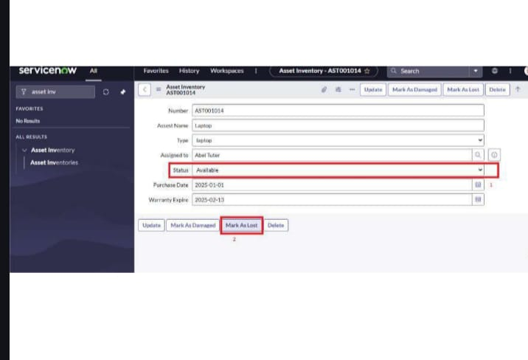

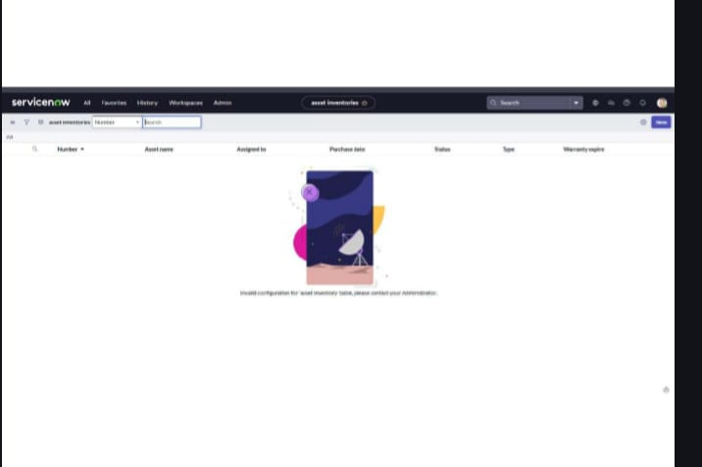

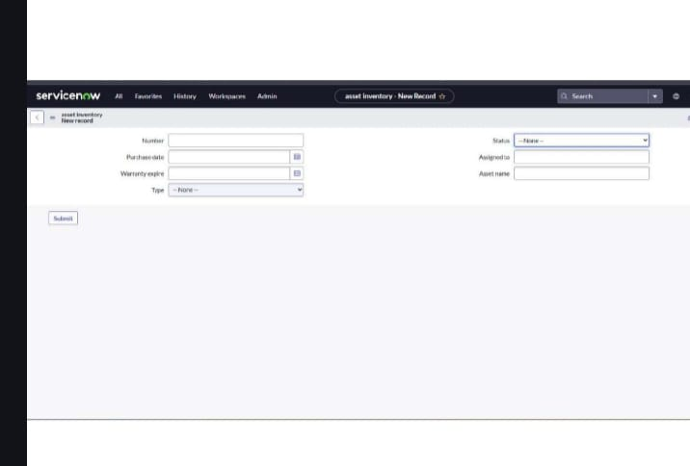

**Advantages and Disadvantages:**

**✅ Advantages of Using ServiceNow for Asset Management Portal**

**1. Centralized Control**

**All physical and digital assets can be tracked from one place using ServiceNow's CMDB, making it easy to manage the entire lifecycle.**

**2. Automation**

**Using Flow Designer, you can automate tasks like asset approval, assignment, and notifications, reducing manual effort and errors.**

**3. User-Friendly Interface**

**Employees can request assets easily using the Service Catalog, which provides a clean and intuitive portal experience.**

**4. Real-Time Updates**

**ServiceNow gives instant visibility into asset status, usage history, and condition, which helps in making informed decisions.**

**5. Alerts and Notifications**

**Maintenance or replacement alerts can be triggered automatically, ensuring timely service and reducing asset downtime.**

**6. Reports and Analytics**

**The platform supports dashboards and performance analytics, which help administrators track asset usage and prevent losses.**

**7. Role-Based Access**

**Different user roles (employee, manager, admin) can be easily managed, improving data security and responsibility handling.**

**❌ Disadvantages of Using ServiceNow for Asset Management:**

**1. High Cost**

**ServiceNow is a premium platform, and licensing costs can be high, especially for smaller organizations.**

**2. Learning Curve**

**Developers and admins need proper training to understand how to use CMDB, Flow Designer, and scripting.**

**3. Customization Limitations**

**While it supports low-code development, some advanced features still require coding in JavaScript or Glide.**

**4. Integration Complexity**

**If your organization uses other tools (like ERP systems), integration with ServiceNow may need custom APIs or connectors.**

**5. Performance Issues if Not Optimized**

**Complex workflows or too many records without optimization can slow down the system.**

**Future scope:**

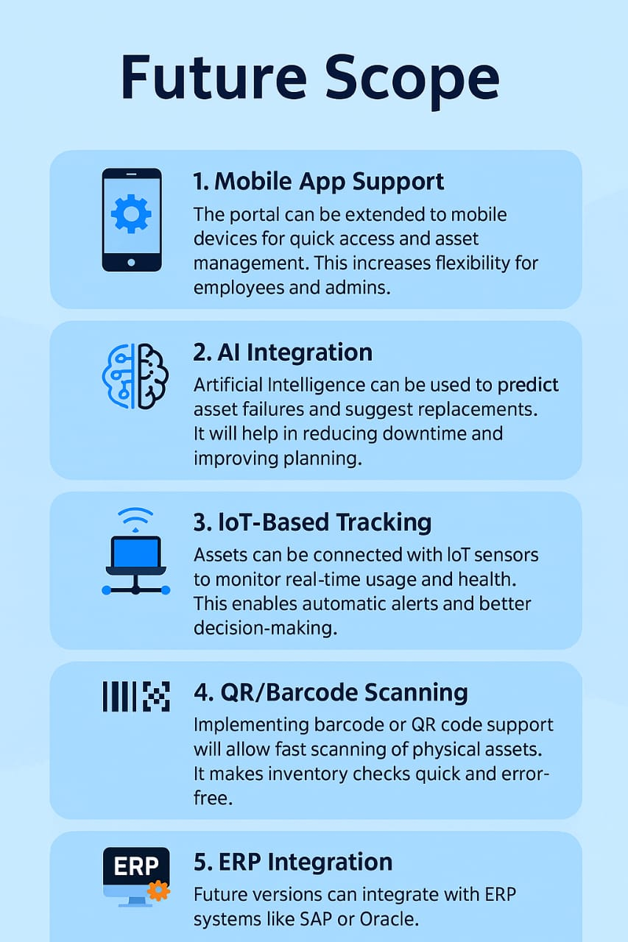

**Conclusion:**

**✅ The Asset Management Portal offers a smart and efficient solution for managing physical and digital assets within an organization. By automating asset tracking, assignment, and maintenance using ServiceNow, the portal ensures improved accuracy, reduced downtime, and better decision-making. It not only simplifies asset-related tasks for employees and administrators but also enhances overall operational efficiency. With features like real-time reporting, centralized data, and alert mechanisms, the system helps minimize asset loss and supports the organization's growth in a structured and reliable manner.**